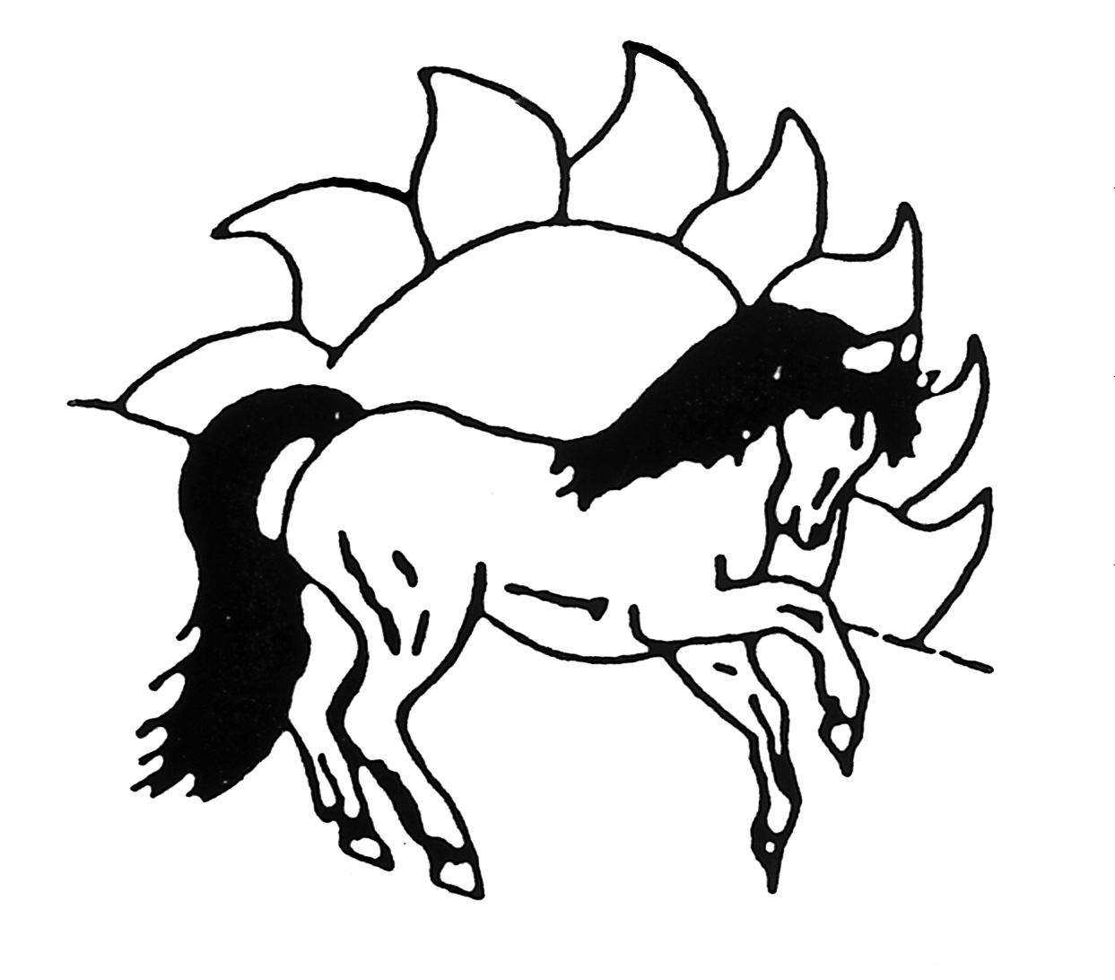 Sunnybrae Pony Club Inc.

Agistment Application
Please print clearly. All details must be completed.

SURNAME:

GIVEN NAMES:

DATE OF BIRTH: AGE:

ADDRESS: _________________________________________________________

POSTCODE:

POSTAL ADDRESS (if applicable):

PHONE NUMBER: WORK:

EMAIL:

PREVIOUS AGISTMENT REFEREE NAME & CONTACT NUMBER:
(List 2 where applicable)

1._________________________________________________________________

2._________________________________________________________________

YOUR EMERGENCY CONTACTS:

NAME: ______________________________ RELATIONSHIP: ________________

PHONE NUMBER: ____________________________________________________

NAME: ______________________________ RELATIONSHIP: ________________

PHONE NUMBER: ____________________________________________________

VET’S NAME: __

Sunnybrae Pony Club Inc.

HORSE/PONY NAME: ____________________________________ AGE: ________

HEIGHT: ________________ COLOUR: ____________________________________

SEX: ____________ BREED: ______________________ (Stallions NOT permitted)

LIST ALL KNOWN VICES: (Including but not limited to – Wood chewing, Cribbing, Windsucking, Biting, Kicking)

__________________________________ ___________________________________

________________________________________ __________________________________________

________________________________________ __________________________________________

- - - - - - - - - - - - - - - - - - - - - - - - - - - - - - - - - - - - - - - - - - - - - - - - - - - - - - - - -

I have read the Agistment Contract thoroughly and agree to abide by all conditions outlined in the Agistment Contract. I understand that I must pay agistment 4 weeks in advance and that my payments must remain 4 weeks in advance at all times to remain agisted on the grounds. I understand that agistment is conditional upon my active participation in at least 60% of the Club rallies and activities in a calendar year.

Applicants name (print): _______________________________________________

Applicants Signature:
(Parent signature if applicant under 18 years of age)

Date signed: ________________________________________________________

PLEASE NOTE
Agistment on the Sunnybrae Pony Club grounds is offered at the absolute discretion of the Club Committee and is not an automatic right of all riding members. Agisters may face suspension or eviction if they do not follow the Rules of Agistment. Applications can only be made after successfully completing an active (3) three-month Membership probationary period. At times due to numbers, waiting periods may apply for mares.

